UNIT IV

- 4.1 Analgesics – Definition – Classification – Narcotic and Non- narcotic – Antipyretic analgesics – Mechanism of action – Morphine and its derivatives – Pethidine and Methadone – Salicylic acid derivatives - Antipyretics and Anti- inflammatory Agents – Definition and Actions – Aspirin, Paracetamol, Ibuprofen – Disadvantages and Uses.

- 4.2 Anaesthetics – Definition – Classification -Local and General – Volatile – Uses of volatile liquids as Inhalation Anaesthetics – Chloroform – Gaseous Anaesthetics – Nitrous oxide, Ether and Cyclopropane – Uses and Disadvantages – Intravenous Anaesthetic Agents – Thiopental sodium, Methohexital and Propanidid.

- 4.3 Drugs affecting CNS – Definition, Distinction and Examples for Tranquilizers, Sedatives (Phenobarbital, Diazepam) – Hypnotics, Psychedelic Drugs -LSD, Hashish – Their effects.

Reference books:
A text book of pharmaceutical chemistry – Jayashree Ghosh.
Applied chemistry – Jayashree Ghosh.

Analgesics
Analgesics are the drugs which relieve pain by acting on the central nervous system and they reduce pain without loss of Consciousness.
Analgesics can be divided into two main groups namely:
Narcotic Analgesics:
These drugs produce depression of the central nervous system and are mainly of two types.
Natural Analgesics e.g. Morphine, codeine.
Synthetics Analgesics e.g. Pethidine, Methadone.
Non- Narcotic Analgesics
These drugs do not produce depression of the central nervous system. Unlike narcotic Analgesics, the non- narcotic analgesics passes anti-inflammatory and antipyretic effect.
e.g. Salicylates and related compounds.
Narcotic Analgesics:
Natural Analgesics:
Morphine and its derivatives.
Morphine:

    - 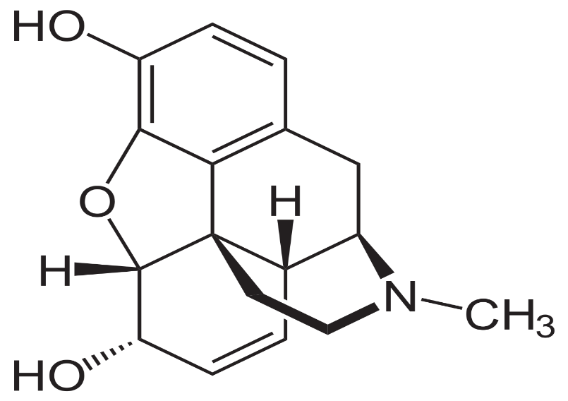
It is an opium alkaloid obtained from unripe seedpods of the opium poppy (papaver somniferum)
It is generally used as sulphate or hydro chloride. Both salts are white colour and both are soluble in water.
Morphine is a phenanthrene – iso-quinoline.
The solutions of morphine are sterilised at 98 C to 100 C for 50 minutes with a bactericide or by filtration.
Analgesics action of Morphine:
It is considered a powerful analgesics. It produces relief of pain in a dose which usually does not alter the other functions of central nervous system.
In large doses morphine can relieve all types of pain. Morphine is reduces pain by increasing the threshold of pain which helps in producing an euphoria (feel to better, Cheerfulness)
These morphine does not remove pain completely but in therapeutic doses, it helps the patient to tolerate the pain and the pain no longer remains as a source of concern.
Side effects:
Respiratory Depression
Nausea
Addiction

Uses:
The main therapeutic use of morphine is an analgesic for relieving the pain morphine is used to reduce pain such as acute myocardial infarction, fractures of bones.
Morphine can be administered intravenously for prompt relief of pain.
It also shows sedative effect and is given to patient with internal bleeding etc.
It also shows finds use in acute left Ventricular failure.
It is invaluable in the treatment of acute pulmonary in edema.
Derivatives of Natural Morphine:
The important derivatives of morphine are Heroin and Apomorphine.
Heroin:

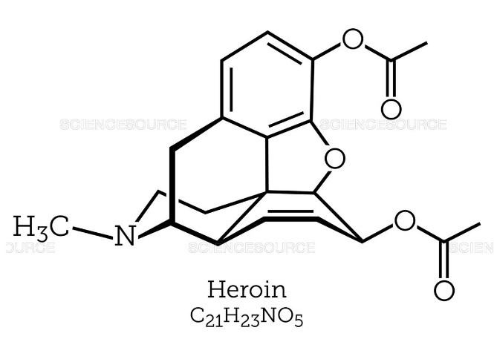
It is a diacetyl derivative of morphine.
It is more powerful analgesic than morphine and produces more euphoria. The tendency of addiction to this drug is much more than morphine and hence this drug is rarely used as analgesics.
Apomorphine:
This drug is obtained by the acid – catalysed rearrangement of morphine.
It induces vomiting within a few minutes. It is administered parentally.
Synthetic Analgesics:
Some important synthetic analgesics are as follows:
Pethidine: (Meperidine)
It us a white, crystalline substance with a bitter tase. It forms salts with acid.

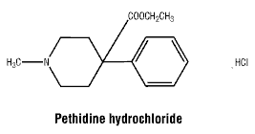
It is Piperidine derivative and its action is similar to that of morphine.
Pethidine is a useful analgesic especially when short duration of action is required.
It is a respiratory depressant like morphine.
It is also used for the treatment of shock.
Methadone:

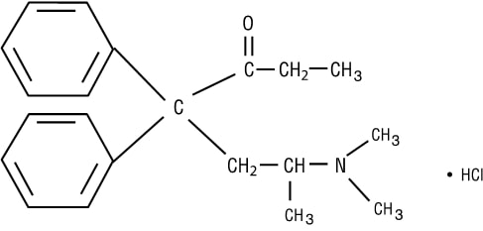
It is obtained as a mixture. Both d and l isomer are active. The l-form is more active.
Methadone is available as methadone hydrochloride tablet doses 5 to 10 mg. It is also available in ampoules in injection form.
Uses:
Its analgesic activity is similar to that morphine.
It is used as a substitute for morphine and pethidine for relief of several visceral pain.
Side effect:
It is also respiratory depressant.
ii) Non – Narcotic Analgesics
These Analgesics also possess antipyretic and anti- inflammatory property.
Antipyretics:
The drugs responsible for lowering the temperature of a feverish organism to normal without any effect on normal states are called as Antipyretics.
Mode of action of antipyretics:
To regulate the body temperature there should exist a balance between the heat produced and heat lost.
Hypothalamus situated in the CNS plays an important role in maintaining this balance. For this reason, the hypothalamus is known as thermostat of the body.
In fever, the thermostatic mechanism is set at higher level. The antipyretics helps to reset the thermostat to the normal level. During this, the heat production is not reduced but the heat loss is increased by increasing the peripheral blood circulation, which in turn increases the rate of respiration.
This results in loss of more heat and makes the body to return to the normal temperature.
Common Antipyretic Analgesics:
Some of the most commonly used antipyretic analgesics are:
Pyrazolone and pyrazolidines
Aniline derivatives
Derivatives of para- amino phenols
Quinoline derivatives
Salicylic acid derivatives
Salicylic acid Derivatives:
The derivatives of salicylic acid are well known for their analgesic and antipyretic action.
The most important drugs are aspirin, sodium salicylate etc.
Aspirin (Acetyl salicylic acid)
It is obtained by the acetylation of salicylic acid in the following manner.

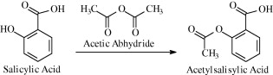

Properties:
It is white odourless , crystalline powder.
It is sparingly soluble in water and has slight acid taste.
` It should be stored in airtight containers.
It is stable in dry conditions. It melts at 135 c.
Uses:
It has antipyretic action.
Aspirin acts on the hypothalamus, increases the peripheral blood flow and sweating, therefore reduce the temperature of the feverish body.
It is used as an analgesic, only in cases in which is mild.
It is used in headaches, colds, arthritis, tooth ache, etc.
It is also used as an anti-inflammatory agent.
It helps in reducing edema, tissue swelling etc. It is also useful as antirheumatic drug and gives relief from signs and symptoms of inflammation.
Methyl Salicylate: (oil of winter Green)
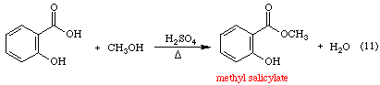
It is obtained by the Esterification of salicylic acid in the following manner:
Chemically it is O-hydroxy methyl benzoate.
Properties:
It is a colourless pale yellow liquid substance.
It has a sweet taste and characteristic aromatic odour.
Uses:
Methyl Salicylate ointment is made in white bee wax and hydrous wool fat.
Sodium Salicylate:
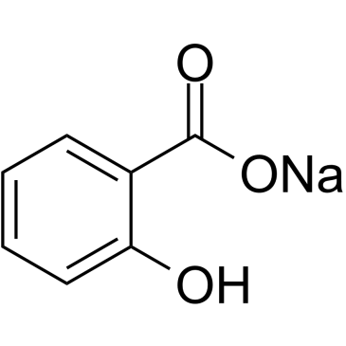
Properties:
It occurs as colourless small crystals or as crystalline powder.
It has unpleasant taste and is soluble in water.
Uses:
It is mainly used for integumental pain, acute rheumatic fever.
Paracetamol:
Preparation:
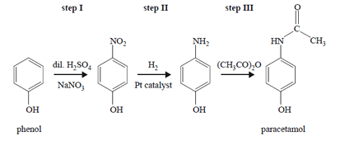
It is 4-hydroxy Acetanilide.
Properties:
It is white crystalline solid.
It is odourless and highly soluble in water.
The total daily does should not exceed 2.5% in adults.
Uses:
It is used as antipyretic and analgesic. It is used for relief of pain and fever.
Adverse Effect
Sweating
Nausea
Vomiting etc.
Ibuprofen:
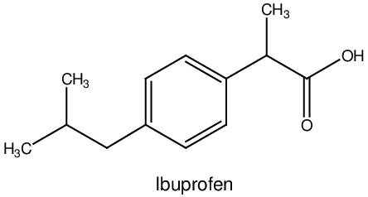
It is isobutyl phenyl propionic acid. Chemically it is named as 2-(4-iso butyl phenyl)-propionic acid.
Properties:
It is a white crystalline powder
It is soluble in water.
Uses:
It has analgesic and week anti-inflammatory action.
It is used in rheumatoid disease.
Its analgesic action is less than that of aspirin.
Adverse Effects:
Head ache.
  - Anaesthetics:
Anaesthesia is reversible loss of sensation and consciousness. Drug which produces anaesthesia are anaesthetics. Anaesthetics produces insensibility to the vital function of all types of cells especially those of nervous system.
Priestley discovered. The first inhalation anaesthetic, Nitrous oxide in 1776. Later on in 1846, marton. Showed the use of anaesthetics in surgical operation.
It produces temporary insensibility to pain or feeling in the body or a particular organ which has to undergo surgical operation. (Anaesthetic agent should have the following characteristics).
It should be able to give enough relaxation time for the surgery to be performed.
It should be inert, non-inflammable and should be non-irritating to the mucous membrane.
It should not have any toxic effect on heart, brain, liver, kidney, etc.
It should be stable to light and heat.
It should not reduce the blood pressure drastically.
It should not induce vomiting or nausea
It Should not give any adverse effed with the administration of other drugs.
It should be economical
It Should have analgesic action and muscle.
It is difficult to find an anaesthetic agent having all these qualities, but these can be combined with suitable ancillary drugs to make it an ideal anaesthetics.
Anaesthetic are Classified into Two Major Classes:
- General Anaesthetics
- Local Anaestetics
General Anaesthetics:
General anaesthetics produce anaesthesia (unconsciousness) to whole the body by depressing the central nervous system.
e.g: Ether, Chloroform, etc.
Action of General Anaesthetics:
According to lipid theory, it is said that efficiency of a general anaesthetic is directly proportional to its affinity for the lipids. The central nervous system is rich in lipids and chemicals (drugs) with high lipid solubility can easily penetrate into the central nervous system and produce anaesthesia.
General anaesthetics are further classified as:
Volatile General Anaesthetics
Non-Volatile General anaesthetics or intravenous anaesthetics.
Volatile General Anaesthetics:
This group includes two type of drugs which are. i) volatile liquids or ii) gases
e.g: Ether, Cyclopropane and Nitrous Oxide, etc.
The anaesthetic activity of volatile anaesthetics can be divided in to four stage which are different from each other. These stages are.
Stage of Analgesia:
This stage, stretches from the beginning of inhalation to loss of consciousness.
Stage of Delirium
This stage is from the loss of consciousness to the beginning of surgical anaesthesia.
Stage of Surgical Anaesthesia:
At this stage patient starts deep breathing
Stage of Respiratory Paralysis:
This stage is characterized by served depression of medullary centers.
Some Important Volatile Liquids are as Follows:
Ether:
Diethyl ether, divinyl ether are important general anaesthetics.
Diethyl Ether:

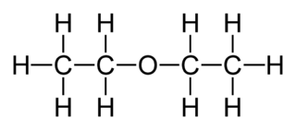
Anasthetic ether is 96-98% diethyl ether
It is eliminated (excreted) through lungs.
Properties:
It is a colorless, volatile liquid with a pungent smell
It boils at 35c.
It is soluble in organic solvents like alcohol, chloroform, benzene
It is insoluble in water
It is highly flammable liquid and is chemically inert
Medicinal Uses:
It was the first general anaesthetic.
About 8% diethyl ether in are is used in surgical anaesthesia
It Produces muscular relaxation without depressing CNS
It has analgesic action also
It does not modify blood pressure.
Disadvantages:
It produces post anaesthetic nausea and vomiting.
The induction of ether is low
Its boils at low temperature and it is inflammable.
Ether irritates the respiratory tract and causes secretion of saliva. Hence atropine is administered.The recovery is low
Divinyl Ethers:
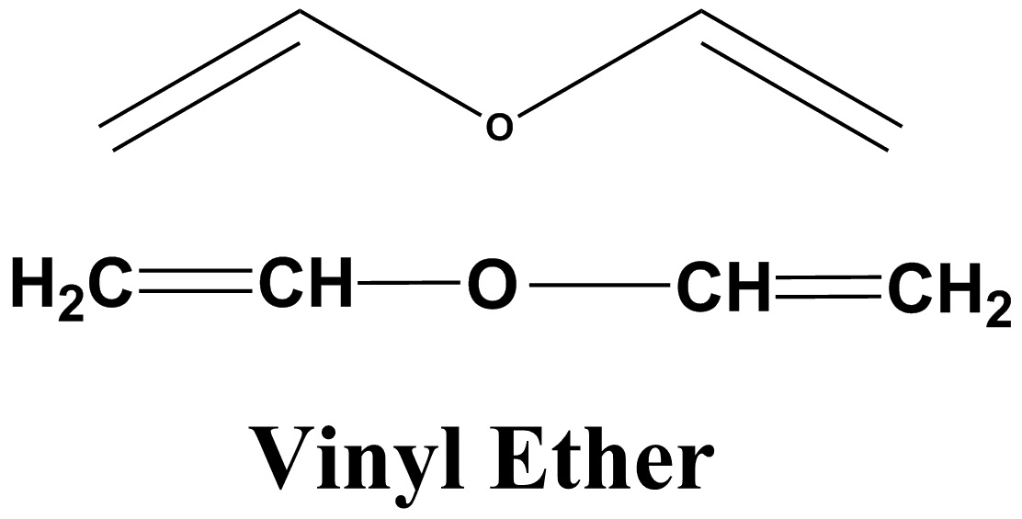
It is unstable in air and light. It is a colorless liquid. It is soluble in alcohol, ether etc.
Uses:
It is used for short anaesthesia and induction anaesthesia.
It is used for minor surgery.
It is useful for dental procedures.
Disadvantages:
It damages liver
It is inflammable
Methoxy Flurane:
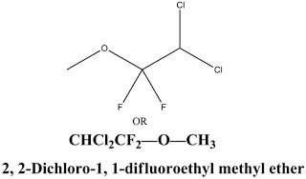
It is a liquid with fruity odour boiling at 101c.
Disadvantages
The main disadvantage is its long stay in body and bioconversion to fluoride which cause renal failure.
Medicinal Used:
Methoxy flurane vapours produce anaesthesia with slow onset and long duration of action.
It Produces muscular relaxation and analgesia. Hence used in obstetrics.
Chloroform:
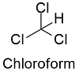
It is a powerful volatile liquid anaesthesia
It is prepared from bleaching powder and ethyl alcohol as follow:
Oxidation, Chlorination and Hydrolysis methods
Properties
It is a colorless volatile liquid having a characteristic odour.
It is miscible with ether and ethanol
In chloroform, 1 to 2% ethyl alcohol is added to prevent the formation of poisonous carbonyl chloride.
It should be protected from light forms toxic phosgene.
Advantages:
Chloroform induction is prompt and its vapours are not flammable.
It is used for obstetrical anaesthesia.
Disadvantages:
It has several toxic effects, particularly
It is very toxic to liver and kidney
Due to its toxicity chloroform is no longer in use as anaesthetics
Trichloro Ethylene:
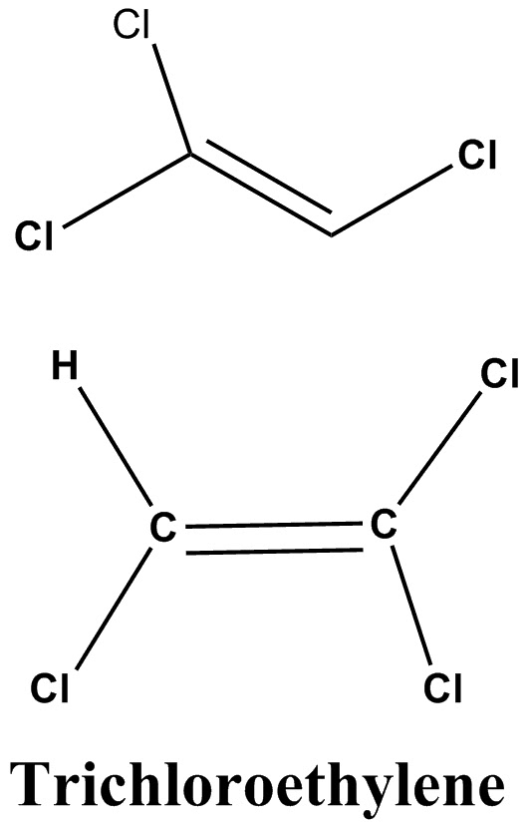
It is prepared by the following method
Properties:
It is colourless or blue coloured volatile liquid having a characteristic odour.
Its boiling point is 86c
It is not miscible with water but is miscible with alcohol, chloroform and ether.
Thymol is added in it as a preservative.
It should be stored in airtight and light resistant containers and should be kept in cool places.
It is less toxic than chloroform
Advantages:
It is a potent analgesic action.
It is recommended for short surgical procedures such as manipulations, dental extractions etc.
Disadvantages:
It breaks down in presence of soda lime to highly toxic products and hence it cannot be used in closed circuit
It produces poor muscle relaxation

Some important gaseous anaesthetic are as follow:
Nitrous Oxide:
It is obtained by heating ammonium nitrate up to 200c as follow:
Structure
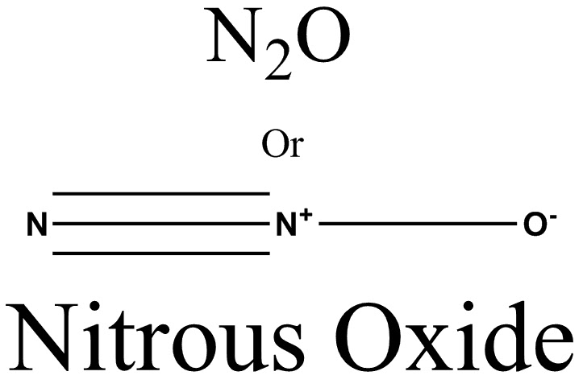

Properties:
It is colourless inorganic non-irritating gas.
It has a sweet taste
It is non-flammable
It is also Known as laughing gas
It is not altered within the body and is eliminated through lungs with 2 to 5 minutes after its withdrawal.
Advantages:
It is one of the safest anaesthelic agent rapid recovery.
It has a very noticeable analgesic action and is employed for tooth extraction. Obstetrical (child birth), painful procedures like changing and cleaning burn wounds etc.
Nitrous oxide is used with oxygen to induce anaesthesia which is then maintained by etc. This technique is called gas - oxygen - ether technique.
It is non-flammable and is non-irritating
Disadvantages:
It is not a potent anaesthetic.
It may produce violent excitation.
It may increase cardiac irregularities.
Hypoxia (a state of diminished oxygen) may be produced during prolonged nitrous oxide anaesthesia.
Cyclo propane:
Structure
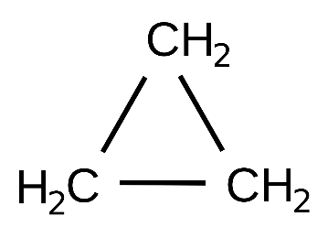
It is obtained from1,3- dichloro propane as follows.
Properties:
It is a colourless gas. It is available in metal cylinders in compressed form.
It should be kept in cool place.
Advantages:
It is a potent anaesthetic and has a fast induction. Recovery is also rapid and smooth.
It is rapidly eliminated through the lungs.
It is a good muscle relaxant. It does not produced irritation of respiratory passage.
It is used in chest surgery, since it controls respiration.
It is valuable anaesthesia fir abdominal Surgeries in pulmonary infections or heat disease, because it produces quiet breathing. Hence there is enough supply of oxygen.
Disadvantages:
If induction is not done carefully, it is produces tachypnoea breath- holding, coughing etc.
It depresses respiratory centre.
Anaesthetic mixture of cyclopropane and oxygen is explosive.
It may produce cardiac irregularities.
It may increase capillary oozing.
NON – VOLATILE GENERAL ANAESTHETICS OR INTRAVENOUS ANAESTHETICS:
These anaesthetics produce unconsciousness when they are administered parenterally.
e.g. Thiopental sodium, Methohexitone, propanidid.
THIOPENTAL SODIUM:

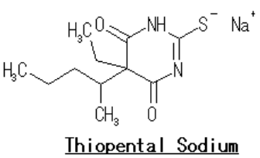
It is derivative of barbituric acid. Chemically it is named as sodium – 5- ethyl -5(2-pentyl)-2-Thio barbiturate.
When administered intravenously, it produces complete anaesthesia of short duration.
Uses:
It is used as anaesthetic agent for operations of short duration, fracture, dental surgeries etc.
ADVANTAGES:
It does not effect respiration and recovery is fast.
It is non explosive. Its induction is rapid and without any unpleasant feeling or irritation.
DISADVANTAGES:
It is a poor analgesic. It does not produce adequate muscular relaxation.
METHOHEXITONE:
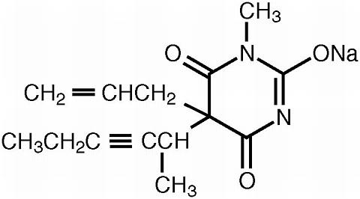
Chemically it is named as sodium -1-(N-Methyl)-5-allyl-5-(2-pentyl)-barbiturate.
It is used as its sodium salt and is more potent than thiopentone.
It is used as 1% solution in injection and is less irritant to vein than thiopental.
USES:
It is used as anaesthetic agent for operations of short duration such as fracture, dental surgeries.
It is advantages and disadvantages are similar to thiopental sodium.
PROPANIDID:
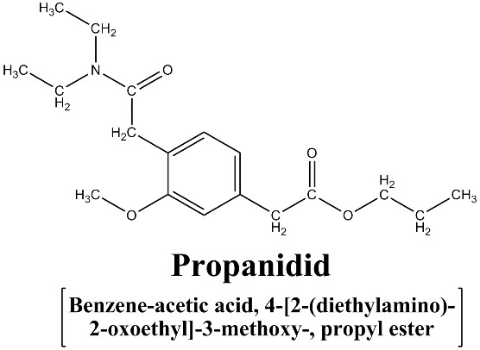
It is an ultrashort- acting intravenous anaesthetic. Anaesthesia last for 5 minutes.
It is used for minor surgery.
  - TRANQUILLIZERS
The main action of a tranquillizers is the control of anxiety and psychomotor agitation without producing sleep or clouding of consciousness.
The best members of this group are chlorpromazine and reserpine.
One of the most important characteristics of chlorpromazine is the ability to reduce psychomotor activity without impairing intellectual functions. Reserpine may serve to block incoming sensory information.
Examples:

Equanil (controlling depression and hyper tension), valium (diazepam), veronol, meprobamate (relieving stress), chlordiazepoxide, serotonin etc. are mild tranquilizers. Other examples are amytal, seconal, librium,
SEDATIVES
Sedative are the drugs which depress the central nervous system and produce sedation. They can be broadly classified as barbiturates and non-barbiturates.
Examples: phenobarbital, diazepam
Phenobarbital
Phenobarbital, also known as phenobarbitone or by the trade name Luminal, is a medication of the barbiturate type. It is recommended by the World Health Organization for the treatment of certain types of epilepsy in developing countries. In the developed world, it is commonly used to treat seizures in young children, while other medications are generally used in older children and adults.
It may be used intravenously, injected into a muscle, or taken by mouth. The injectable form may be used to treat status epilepticus. Phenobarbital is occasionally used to treat trouble sleeping, anxiety, and drug withdrawal and to help with surgery.
Diazepam
Diazepam, first marketed as Valium, is a medicine of the benzodiazepine family that acts as an anxiolytic. It is commonly used to treat a range of conditions, including anxiety, seizures, alcohol withdrawal syndrome, benzodiazepine withdrawal syndrome, muscle spasms, insomnia, and restless legs syndrome.
Hypnotics
Hypnotic, or soporific drugs, commonly known as sleeping pills, are a class of psychoactive drugs whose primary function is to induce sleep and for the treatment of insomnia, or for surgical anesthesia.
PSYCHODELIC DRUGS (LSD AND HASHISH)
These drugs are used principally as investigative tools to aid the understanding of biochemical and metabolic disturbances in psychosis.
e.g., LSD And Hashish.
Lysergic acid diethylamide (LSD):
This is a derivative of ergot alkaloids. It is used as a tool in psychiatric research. It induces psychiatric states in which repressed memories and other material in the unconscious mind are brought to light. It is a powerful cytogenetic agent inducing chromosomal abnormalities and possibly leukaemia. The structure of LSD is given below:
